**Library Module – Shared Library**

**1. Create 3 files as below.**

* **libapplication.c – will contain main() and will invoke functions in cal_utility.c**
* **cal_utility.c – will contain atleast 2 or more functions [ You may add definitions of the functions in this file]**
* **cal_utility.h – will contain the extern declarations/prototypes of the functions in cal_utility.c**

**Ans :**

libapplication.c

cal_utility.c

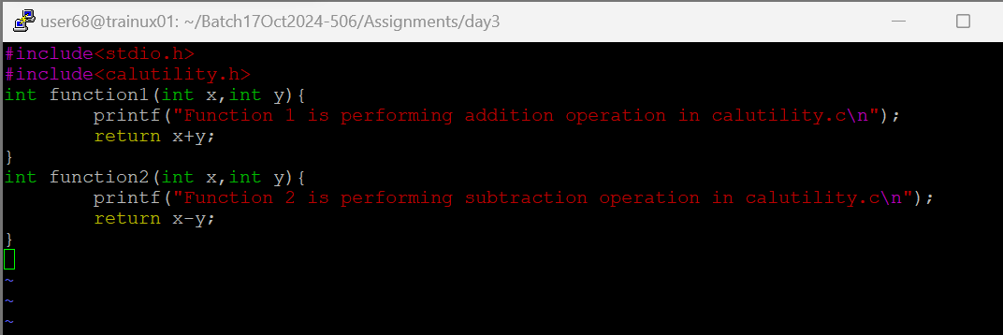

cal_utility.h

**2. Refer the  steps for shared library and create a shared library comprising of cal_utility.c,.h files**

Ans: gcc -FPIC -c cal_utility.c

gcc -shared -o libcalutility.so calutility.o



**3. Create an executable using shared library.**

**ANS:** gcc -o apllication libcalutility.c -L. lcalutility



**4. Execute the application created step 3.**

**Ans:** ./application

